Experiment:25 Date:18/08/2027

DIETING SYSTEM BASED ON DISEASE

Aim
To write a Prolog program to suggest suitable food based on a given disease.

Algorithm
- Start the program.
- Define different diseases.
- Define suitable food items for each disease.
- Create a rule to suggest food based on disease.
- Query the disease and display the suggested diet.

PROGRAM:
diet(diabetes, low_sugar).
diet(diabetes, vegetables).
diet(diabetes, whole_grains).
diet(hypertension, low_salt).
diet(hypertension, fruits).
diet(hypertension, vegetables).

diet(obesity, low_fat).
diet(obesity, fruits).
diet(obesity, vegetables).
suggest(Disease, Food) :-
diet(Disease, Food).

OUTPUT:

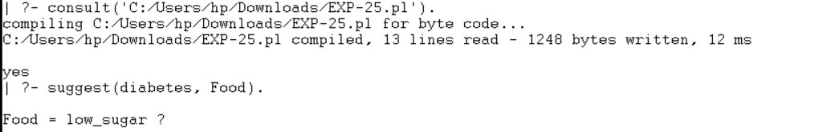

RESULTS:
Thus, the Prolog program was successfully executed to suggest a diet based on disease.

